Diff. Chemistry & IB Chemistry I: Conversions review Name

I. Setting up conversions: Convert the following and show ALL your work.

1. 3770 mL to L 2. 37 g to kg 3. 6300 nm to m 4. 2.30 x 10⁻³ mL to μL

II. Put the following measurements in order of increasing magnitude. Show all your work.
5. 300 mg, 1,500 g, 1 kg 6. 2320 cm, 2.2 x 10² in, 11.8 yds

7. 32,000 nm, 42.0 μm, 6.540 x 10⁻⁵ m 8. 6,300 mL, 3.55 gal, 1.69 x 10⁻⁴ m³

9. 387.1 K, 111.4 ºF, 63.8 ºC 10. 3.76 x 10³ cal, 4.19 x 10⁻² kJ, 3.22 x 1024 eV

III. Solve the following questions. Show ALL your work.

1. Batrachotoxin, the active component of South American arrow poison obtained from the golden frog (Phyllobates terribilis), is so toxic that a single frog contains enough poison (1100 µg) to kill 2200 people. How many micrograms would it take to kill one person?

2. The white blood cell concentration (w.b.c.) in normal blood is approximately 5000 cells/mm³. How many white blood cells does a normal adult have? Assume that the total blood volume in a normal adult is 5 liters.

3. The density of liquid bromine is 3.12 g/mL. What is the mass of 0.500 L of bromine?

4. A pound of coffee beans yields 50 cups of coffee. How many liters of coffee can be obtained from 1500 g of coffee beans?

5. What is the area of a baseball diamond in acres? (A baseball diamond is a square whose side is 90 feet in length.) 1 acre = 43, 560 square feet

6. Analysis of an air sample reveals that it contains 3.5 x 10⁻⁶ g/l of carbon monoxide. Express the concentration of carbon monoxide in lb/ft³.

IV. Answer the following questions about waves. Be sure to show ALL your work.
1. What is meant by the "frequency of light"? What symbol is used for it, and what is the SI unit for frequency?

2. Sketch a diagram of a wave and label its wavelength and its amplitude.

3. Give the equation that relates the wavelength and frequency of a light wave to the speed of light.

4. What is the frequency in hertz of blue light having a wavelength of 425 nm?

5. Ozone protects the earth's inhabitants from the harmful effects of ultraviolet light arriving from the sun. This shielding is a maximum for UV light having a wavelength of 295 nm. What is the frequency in hertz of this particular wavelength of UV light?
6. Sodium vapour lamps are often used in residential street lighting. They give off a yellow light having a frequency of 5.09 X 10¹⁴ Hz. What is the wavelength of this signal in nanometers?

7. Some earthquake waves travel at 5 km/sec. What is the wavelength of these waves if the earth tremors are 10 per second?

8. Calculate the energy in joules/photon for green light having a wavelength of 550 nm.

9. Microwaves are used to heat food in microwave ovens. The microwave radiation is absorbed by moisture in the food. This heats the water, and as water becomes hot, so does the food. How many photons having a wavelength of 3.00 mm would have to be absorbed by 1.00 g of water to raise its temperature by 1ºC? It takes 4.184 J of energy to heat this much water.

10. The wavelengths of X-rays are much shorter than those of ultraviolet or visible light. Show quantitatively why continued exposure to X-rays is more damaging than exposure to sunlight.

11. Rubidium has two common isotopes, ⁸⁵Rb and ⁸⁷Rb. If the abundance of ⁸⁵Rb is 72.2% and the abundance of ⁸⁷Rb is 27.8%, what is the average atomic mass of rubidium?

12. Silver consists of 2 naturally occurring isotopes: silver-107, which has a mass of 106.90509 g/mol, and silver-109, which has a mass of 108.9047 g/mol. The atomic weight of silver is 107.8682. Determine the isotopic abundance of each isotope in naturally occurring silver.

V. Topic 2 Review Questions

1. Fill in the missing parts of the chart

Name symbol atomic # mass # # of electrons # of protons # of neutrons
a. carbon-14 ___ ____ 14 ____ ____ ____

b. ________ ⁶⁸Zn⁺² ____ ____ ____ ____ 38

c. ________ ___ ____ ____ 18 16 18

2. Explain what the following radioisotopes are and provide TWO uses for each

a. iodine-131

b. phosphorus-32

c. cobalt-60

d. (one of your choice)

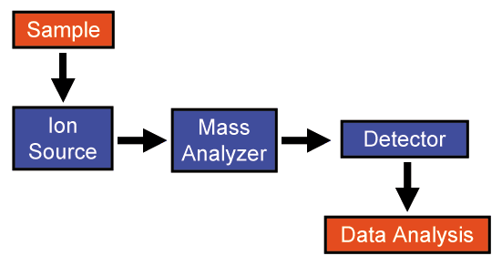
3. To the right is a diagram outlining the parts of a mass spectrometer. Briefly describe what is happening in the three middle phases.

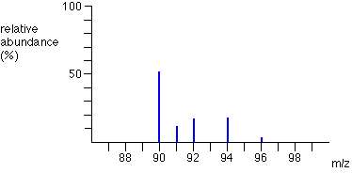

4. To the right is a mass spectra of a zirconium sample. From the data obtained, estimate the atomic mass of this sample.

5. From knowing the abundances of each isotope from #4, calculate the atomic mass of zirconium

zirconium-90 |  | 51.5
zirconium-91 |  | 11.2
zirconium-92 |  | 17.1
zirconium-94 |  | 17.4
zirconium-96 |  | 2.8

6. Fill out the table below for spectral emission lines associated with electron movement in a helium atom

(n_{i} → n_{f} ) | Energy | Wavelength | Frequency | Wave type
2 → 1
3 → 1
3 → 2
4 → 1
4 → 2
4 → 3

7. Write electron configurations for the following element’s atom or ion:

a. Ca

b. Se⁻²

c. Fe⁺³

d. Cu

