IB Group 4 Lab Report Guide
- Lab reports make up 24% of your final grade.
- This is a guide to help you with your lab reports. Use it!

I. Parts of a Lab (IA) Report
1. Introduction:
a. title
b. aim
c. research question/hypothesis
d. variables
e. control of variables
2. Materials & Methods
a. materials
b. method
3. Data
a. raw data
b. uncertainty
c. presentation (tables)
4. Results/Conclusion
a. processing data
b. Graphs

5. Discussion
a. Conclusion
b. Evaluation
6. References

II. IA Description
A. Design
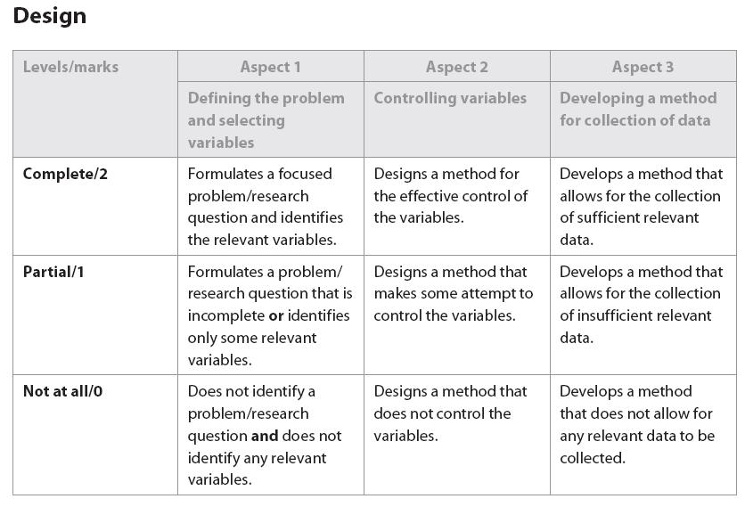
I. Research Question
Rather than an Aim and Hypothesis you need to start your Design practicals with a focused research question. A Design practical has a title that is deliberately vague. You, the student, are expected to come up with the independent variable. Use the independent variable and the dependent variable to phrase your research question. You should also include a brief description of your experiment.

Eg. What is the effect of a changing glucose concentration on cell respiration in yeast? Five different concentrations of glucose (0.0 M, 0.25 M, 0.50M, 0.75M and 1M) will be used to see how the growth of yeast changes. The growth of yeast will be measured by the amount of CO₂ produced which is an indication of the amount of cell respiration taking place. It is expected that increasing the glucose concentration will increase the amount of C0₂ produced which will suggest that the rate of cell respiration has increased.
II. Hypothesis
While a hypothesis isn’t needed and sometimes it’s not possible, usually in biology you will have a hypothesis. If you include a hypothesis to help focus your research question then it needs to be an “if….then…” statement that includes the independent and dependent variables. Your hypothesis should be supported with an explanation.

Eg. If the glucose concentration is increased, then the amount of C0₂ produced will also increase. This is because glucose is used by yeast to make ATP through cellular respiration. The more glucose that is available, the faster the rate of cell respiration, and the more C0₂ that will be produced. C0₂ is a product of cell respiration in yeast, so the more C0₂ the faster the rate of cell respiration.

III. Variables
Remember to correctly categorize your variables and think of as many controlled variables as you can. That said, don’t include controlled variables that aren’t significant. For example if you’re measuring the growth of yeast then the temperature definitely needs to be controlled (assuming temperature is not your independent variable) but the same location is not going to be a significant factor. For those who can’t recall or have never learnt how to categorize variables:
Independent: The variable that YOU change.
Dependant: The variable that changes when you change the independent variable (what you measure).
Controlled: All the aspects of the experiment that must be kept constant to ensure that the tests/experiment is fair. There will be several of these not just one!

Make sure that you choose only one independent variable to change. Some people inadvertently choose more than one.

IV. Control of Variables
Your must explicitly indicate how each controlled variable identified in your variables section was controlled. If you can’t actively control a variable then your method should include a means of monitoring it.

V. Materials
In a Design practical you need to choose the apparatus and submit an equipment request. Make sure you plan thoroughly and don’t leave anything out. If you need something extra that you didn’t put on your list it will be provided but you will receive a partial for the first aspect of this criterion. The same thing applies if you “borrow” from another group. Of course if you try and persist with what you have but I can see that it’s clearly not enough, well that’s a partial too.

Make sure when writing up your equipment list that you include:
• The sizes of glassware such as beakers, flasks, etc.
• The concentration of chemicals (eg hydrochloric acid, 2.0 M).
• The amounts of chemicals (eg magnesium, 0.50 g).
• The range of a thermometer (eg –20°C to 120°C)
• The amount of each solution (eg 200 mL)

VI. Method
You will write your own method, I won’t supply one for you to “copy”. Use “impersonal language”; which means no words such as “I”, “we”, “they”, “you” etc.

Eg: “I weighed out 0.50 g of magnesium and then I added 2.0 cm3 of 2M hydrochloric acid”
should be rewritten as “Add 0.5 g magnesium to 200 cm3 of 2M hydrochloric acid”

Make sure you record the amounts of materials to a sufficient precision in your method.

Eg: If you weighed 20 g of magnesium using a volumetric pipette this should be recorded as 20.00 g and not just 20 g.
Why? Because the scale has a precision of two decimal points

Don’t include “obvious” steps in your methods. Steps such as:
“collect and put on safety equipment”
“clean up bench and return apparatus to the trolley”
These steps would be relevant to pretty much any experiment and so don’t need to be included.

While writing up your method in “dot point” or numbered form is acceptable, real scientists actually write their methods in paragraph form – try it.

Your method must explicitly indicate how each controlled variable identified in your variables section was controlled. If you can’t actively control a variable then your method should include a means of monitoring it.

Sometimes the best thing to do for your method is to draw a diagram of the experimental set up and refer to it. That’s fine if you do a diagram that is of a suitable size and reasonably detailed. Don’t sketch some doodle on the back of your report two minutes before you’re about to hand it in. Below on the left is a poor example of a diagram. On the right is a version of the same equipment done well using a basic drawing program.
- Truly, I wish I had a dollar for every report where I’ve seen:
“1. Set up the equipment as shown below:”
only to see below a big blank space. If you intend to draw in a diagram make sure you don’t leave it to the last minute and forget. I’m sure this happens because people write up at home, bring it to school and two minutes before its due to be handed up print it off in a panic. No doubt this is also the cause of many of the sloppy diagrams referred to in the previous point. A missing diagram will mean an automatic partial on the second aspect.
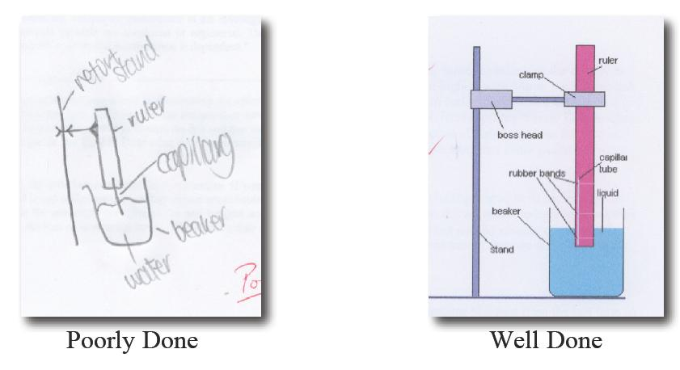

When designing a method ensure that you change the independent variable enough times to collect enough points for a reasonable line of best fit. A minimum of five data points is required for any graph and more should be collected if time and materials allow.

Consider whether or not the graph needs many data points or whether more repeating would be more worthwhile. If the graph has a complex shape e.g. a titration or cooling curve, then the more points the better. If the graph is linear then repeating the experiment for each point would be a better way to improve the correlation coefficient than simply collecting more points (assuming you already have 8 – 10 points).

The method should include sufficient repeats of trials to ensure that random errors are at least minimised. Don’t leave this for your evaluation as repeating the experiment is a pretty lame suggestion – doubly so if you should have had it in your method in the first place.

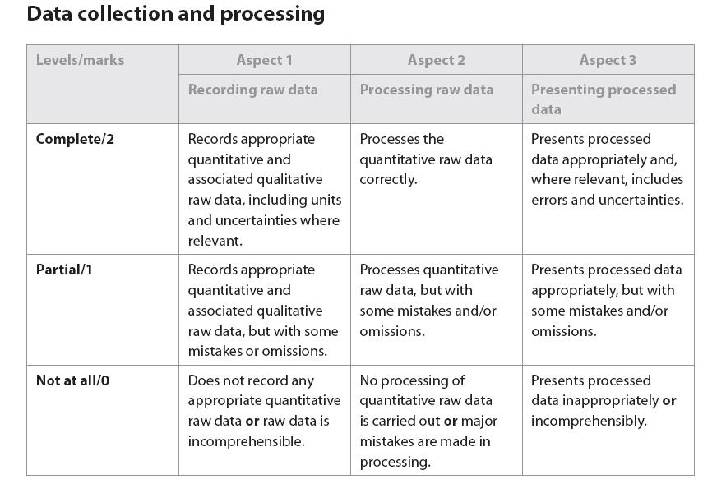
B. Data collection and processing
I. Data (Raw)
There are several aspects to data collection. Don’t overlook any of the following:
• Quantitative data (i.e. numerical values)
• Qualitative data (i.e. observations)
• Uncertainties in apparatus
It is very common for the second of these to be forgotten – and that’s an automatic partial!
Do not record raw data on the task sheet thinking “I’ll write up the neat copy later”. If you choose to record it “rough” on the back of the task sheet it will be marked as your data collection. Ideally you should record your data in a lab book dedicated to that purpose. You are permitted to then type it up neatly for your report.

Don’t mix quantitative and qualitative data in the same column. Sometimes it is appropriate to record qualitative data in a table and sometimes not. Usually it’s pretty clear when to do which.

Make sure you record all of your RAW data. Although, raw data and processed data CAN be in the same table, but this would require you head the section as DATA/RESULTS

Eg: If you are interested in the change in temperature of a reaction record the
Initial and final temperature.
Initial Temp (°C ± 0.5°C): 18
Final Temp (°C ± 0.5°C): 49
Temp Change (°C ± 1.0°C): 31

The temperature change is a result of data processing and cannot be recorded as raw data.

II. Uncertainty
The uncertainty for a piece of apparatus is either printed on the apparatus (eg burette, volumetric glassware) or is half the smallest measurable or cited value.

Eg: If a balance can measure to two decimal places (0.01 g) then the error in a mass reading with this balance is ±0.005 g.
An exception to the uncertainty being half the smallest instrument value is when using a stopwatch. According to the display you can measure time to the nearest 100th of a second (0.01 s) with our stopwatches. Based on this the uncertainty would be ±0.005 s – but somehow I doubt your reflexes are this good. A more reasonable value would be ±0.5 seconds.

III. Data table Presentation
When preparing your tables you must address the following to ensure you receive a complete for the presentation aspect:
• The units must be included. They should be cited ONCE in brackets in each column heading. Don’t put the units after each piece of data.
• The uncertainty of the quantitative data and the units of the uncertainty need to be recorded once in the column heading (see example below).
• All data in a column must be given to the same number of decimal places
• Tables and columns need border
• The data in a column needs to be centered in the column.
• The table needs a suitable and descriptive heading (“Table 1”, “Data Collection” or “Results” are not suitable headings).
• Do not split tables over two pages if your table is not more than one page long.
Leaving any of the above out will result in a partial for the third aspect.
I f there is something peculiar about a piece of data that you wish to draw the reader’s attention to, put
an italicized superscripted letter after the data and make a note under the table.
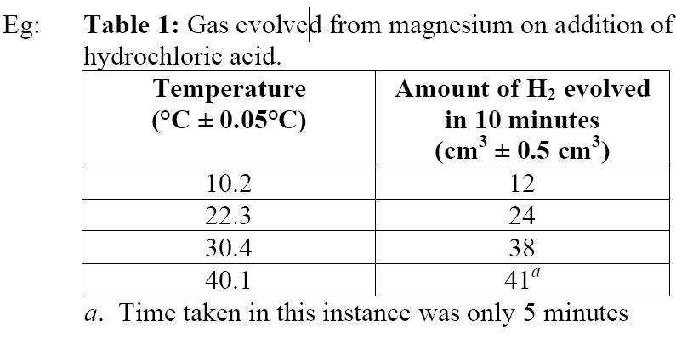
Avoid repetition. For example, if in every experiment you used the same amount of acid just mention it
in the method. You don’t need a column that repeats it over and over in your table.

Take great care with units. The most common mistake is to use mL when you should use cm³.
No-one likes having to hunt through tons of calculations to find final results, least of all me. If the results of repeated calculations aren’t tabulated to facilitate comparison then a partial for presentation will result.

III. Data Processing
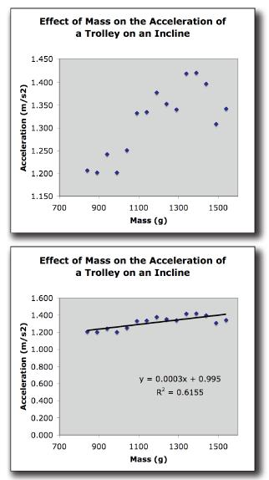
The second aspect is self-explanatory. The only advice needed is to make sure you check your working carefully. If your data processing gives you an answer that is nothing like what you expected, or the literature value(s) given, don’t blame the experiment – you have made a significant error in your data processing.
- Show the equations you used and an example of a calculation. If it is a simple calculation, like an average, you only need to show it once
- Don’t use rounded off values in further calculations. Carry through all the decimal places on your calculator. Using rounded off values can lead to final answers that are out by a decimal place or more. This will result in a partial for the first aspect.
- Use headings where possible to explain what section or step of the calculation you are doing.
- If preparing your reports on a word processor make sure you subscript and superscript characters where necessary.

IV. Graphs
If you use Excel for graphing:
• Plot a scatter x-y graph for continuous data.
• Plot a column graph for categorical data.
• Remove gridlines and legend.
• Add a suitable trendline/line of best fit (in many cases you will have to do this by hand).
• Determine the equation of the line (in trendline options).
• Determine the correlation coefficient (in trendline options).
• If you can’t do all of the above see me or do your graphs by hand!

For Excel and hand-drawn graph
• Give your graph a suitable and descriptive title (“Graph” is not a descriptive title).
• Label axes and include units in brackets.
• Ensure your graph is a suitable size (half page) and not to narrow in either direction.
If you leave any of the above out a partial will be awarded for presentation.

Never, ever, ever join the dots. This will result in an automatic not at all. The same thing applies if you leave out the line of best fit entirely. You must draw a line of best fit – a straight line or smooth curve that has roughly as many points on either side of it.

Use a SHARP pencil – if you don’t a partial will be awarded. A partial will also be awarded if your graph is “hairy”.

No-one likes having to hunt through tons of calculations to find final results, least of all me. If the results of repeated calculations aren’t tabulated to facilitate comparison then a partial for presentation will result.
Take care when interpreting graphs prepared with Excel. By default Excel will use your minimum and maximum data points to select where the axes start and stop. At first glance the graph to the right seems to have a significant upward trend but with a lot of random error! One might think that no reasonable conclusion could be reached from such unreliable data. Appearances can be deceiving. By double clicking on an axis you can alter its properties including where it starts and stops. The data has been plotted again with the y-axis set to start at zero. Now a more logical conclusion can be reached, supported by the calculated gradient of the line and in agreement with accepted theory– mass has no effect on the rate of acceleration. Mind you, the correlation coefficient is still, at best, only fair.

Sometimes you will want to do the opposite – accentuate the gradient by starting the y-axis at a value other than zero.

Conclusion
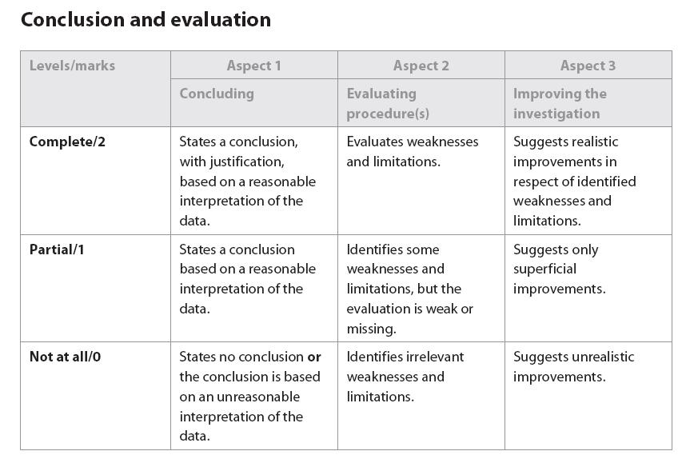
Ensure that you quote any quantitative results in your conclusion even if the quantitative results are mentioned elsewhere in your report. That said don’t just restate your results. Draw conclusions from them.

Remember a hypothesis can only be supported or refuted. It cannot be “proven”!

Don’t forget to compare your results to the literature. This may be quantitative literature values, manufactures claims or established theories. If you are comparing quantitative results express any difference between your value and the literature value as a percentage of the literature value. Statements such as “our results were very close to the literature values” are not enough – how close are they as a percentage?

Conclusions such as “The results confirm my hypothesis” will be awarded not a tall – especially if the results don’t “confirm” your hypothesis and even if they do. You must explain why/how your results support or invalidate your hypothesis. You can do this by referring to specific observations, the gradients/shapes of graphs or values collected/calculated. You need to show that you understand how your results support or invalidate your hypothesis.

Conclusions such as “The results confirm my hypothesis” will be awarded not at all – especially if the results don’t “confirm” your hypothesis and even if they do. You must explain why/how your results support or invalidate your hypothesis. You can do this by referring to specific observations, the gradients/shapes of graphs or values collected/calculated. You need to show that you understand how your results support or invalidate your hypothesis.

Evaluation
i. Evaluating Errors

Analyse your sources of error. Distinguish between systematic and random errors.

Random Errors: Occur randomly usually due to variation in biological tissues.
Systematic Errors: Occur each time the experiment is done because some aspect of the experiment has a consistent error. It may be that a measuring cylinder, or thermometer is inaccurate. Instead of the thermometer reading 25°C when it is 25°C it reads 27°C. So all the temperatures you record using this thermometer will be 2°C out. This may have a significant effect on any calculated values (Or it may not. Consider the significance of possible errors carefully).

Your evaluation of the errors should focus on the systematic and the random errors.

Consider some of the following when preparing your evaluation:
• Are there flaws in the procedures used which could affect the result?
• Were important variables not controlled?
• Are the measurements and observations reliable?
• Is the accuracy of a result unknown because of a lack of replication?
• What assumptions are being made?
Don’t limit yourself to the above or a partial may result.
ii. Improvements
You must suggest improvements to the PROCEDURE. Complaining about not having enough time or being disorganized has nothing to do with the procedure. You need to suggest a minimum of three significant improvements. Anything less will result in a partial. You must explain why the improvements will lead to a reduction in systematic or random error.

Suggestions that lead to increased precision are only worthwhile for experiments that require precise measurements (in an IB Biology class, precision experiments are rare).

Suggestions such as “collect more data”, while valid and should be included with an explanation when appropriate, are fairly obvious and on their own are insufficient to address the last aspect.

Some suggestions such as “be more careful” are lame. All you’re saying with a phrase like this is that you were careless on the day and that I should mark you down for your Manipulative skills – and I probably will, with my thanks for the reminder.

If it helps you can use the following table to help organize your evaluation.

- Weakness/Error
- Impact of Weakness
- Improvements

Referencing
If you use someone else's ideas in your report you need to acknowledge them. This includes in-text referencing and a works citied page.

- IN-TEXT REFERENCING IN YOU EXPERIMENTS
Any information you use in your essay to support your ideas must be referenced within your actual writing. To do this, simply insert appropriate information (usually the author - page number or year) in parentheses after the words or ideas taken from another source. Place them where a pause would naturally occur to avoid disrupting the flow of your writing (usually at the end of a sentence).This then links to the full details of these sources found in the works cited/ bibliography section at the end of your essay. There are two methods on how to do this:
1. USING PARENTHESES: You need to provide the author’s name (if known) and year in parenthesis at the end of your sentence if you do not identify the author in your text:
e.g. It is recommended that the U.S. government develop a new foreign policy to help Third World Countries overcome poverty and hunger (Spitzer 2002)
If you do not know the author, use the title (shortened if necessary):
e.g. It is recommended that the U.S. government develop a new foreign policy to help Third World Countries
overcome poverty and hunger (‘No Need for Hunger’ 2002)

2. Noting Use of Parentheses: You do not need a parenthetical reference if you identify the author in your text. (See the first entry below.)
WITH AUTHOR IN TEXT (This is the preferred way of citing a complete work.)
e.g. In ‘No Need for Hunger’, Robert Spitzer recommends that the U.S. government develop a new foreign policy to help Third World countries overcome poverty and hunger.
WITHOUT AUTHOR IN TEXT
e.g. ‘No Need for Hunger’ recommends that the U.S. government develop a new foreign policy to help Third World countries overcome poverty and hunger (Spitzer).

- REFERENCING INFORMATION IN A WORKS CITED SECTION / BIBLIOGRPAHY

Information you need:

Website
Author’s Last name
Author’s First name
Site Title
Organization
Date accessed
URL

Personal Interview
Name of person interviewed
Type of interview.
Date of interview.
Book/ Encyclopedia, Magazine, etc
Author’s Last name
Author’s First name
Title of book
Publishing City
Year Published
Page Numbers
Publishing Company
Website:
Last Name, First Name. Site Title. Organization. 9 Apr 2007 <URL>.
(if you do not know the author, leave it blank)
Book:
Last Name, First Name. Title of Book. Publishing City: Publishing Company, Publishing Year.

Errors and Uncertainties – More information
Mistakes - errors should not be confused with mistakes, such as spilling half of the chemical you just carefully weighed to the nearest milligram between the balance and volumetric flask. If a mistake is made you just have to start again. As far as your evaluations go you do not need to mention or discuss mistakes – we all make them so don’t worry.

An appreciation of errors should be apparent at all stages of a report on an investigation:
 in the design stage, where the limitations of time and the materials should be assessed, and the potential sources of error should be controlled. This is done by listing your control variables and explaining how you will control them. Remember that you will have more than one control variable
 in data tables and graphs, where the degree of accuracy of a measuring device should be stated as well as other observed sources of error.
At a minimum you should include:
-Accuracy of measuring devices (eg. +/- 0.005 cm) in tables and graphs.
-Error bars on your graphs with a statement in your title stating the range of those error bars. (see figure 1 below)
- A correlation coefficient (R2)
See tables and graphs below for examples:
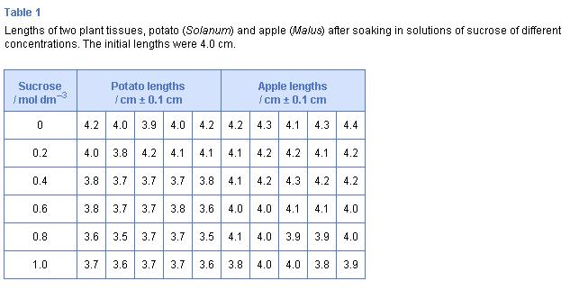
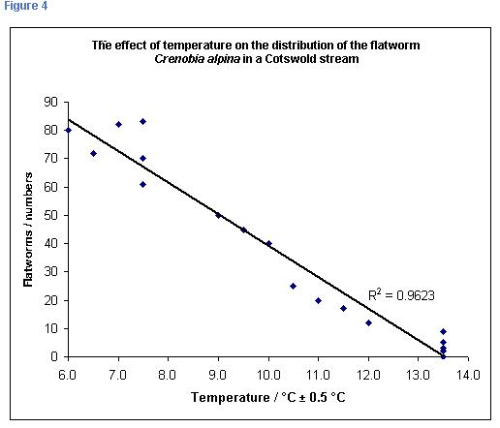
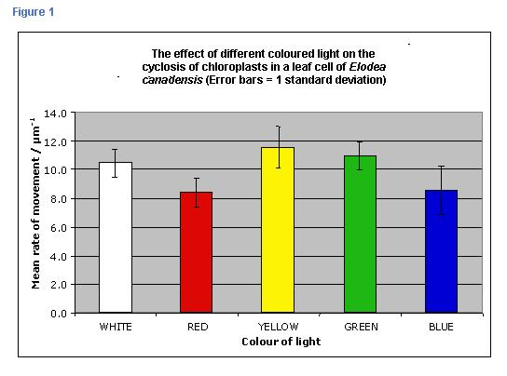
*NOTE: This graph is missing uncertainties (accuracy of measurements).
- in the conclusion and evaluation stage, where the sources of error should be discussed, along with possible ways of avoiding them. (See evaluation)
Terms and concepts in error analysis

Random variation or normal variation
In many investigations, errors can be caused by changes in the material used, or by changes in the conditions under which the experiment is carried out. For example, the water potential of potato tissue may be calculated by soaking pieces of tissue in a range of concentrations of sucrose solutions. However, the pieces of tissue will vary in their water potential, especially if they have been taken from different potatoes. Pieces of tissue taken from the same potato will also show variations in water potential, but they will probably show a normal variation that is less than that from samples taken from different potatoes.
Random errors can, therefore, be kept to a minimum by careful selection of material and by careful control of variables. For example, you could use a water bath to reduce the random fluctuations in ambient temperature.
Human errors can become random when people have to make a large number of tedious measurements and, therefore, their concentration spans vary. Automated measuring, using a data logger system, can help to reduce the likelihood of this type of error. Alternatively, the experimenter can take a break occasionally.

Human errors (mistakes)
Human errors can occur when tools, instruments or protocols are used or read incorrectly. For example, a temperature reading from a thermometer in a liquid should be taken after stirring the liquid and with the bulb of the thermometer still in the liquid. Thermometers (and other instruments) should be read with the eye level with the liquid in the thermometer (reading needle) to prevent parallax error. Human errors can be systematic, because the experimenter does not know how to use the apparatus properly, or they can be random, because the power of concentration of the experimenter is fading.
HUMAN ERRORS are not relevant errors to discuss! We all make mistakes.

The act of measuring
When a measurement is taken, this can affect the environment of the experiment. For example, when a cold thermometer is put into a test tube with only a small volume of warm water in it, the water will be cooled by the presence of the thermometer, or when the behavior of animals is being recorded, the presence of the experimenter may influence the animals’ behavior.
Measurement errors can, therefore, be kept to a minimum by careful selection of material and by careful control of variables.

Systematic errors
Systematic errors can be reduced if equipment is regularly checked or calibrated to ensure that it is functioning correctly. For example, a thermometer should be placed in an electronic water bath to check that the thermostat of the water bath is correctly adjusted. A blank should be used to calibrate a colorimeter to compensate for the drift of the instrument.

Uncertainty - Degrees of precision and uncertainty in data
Uncertainty is not the same as error. A value that is in error is incorrect. It is not a true measure of reality. A value can be entirely correct but, no matter what, it can only be measured to a certain limit of precision – to only so many “decimal places”. This limit of precision is quantified as the uncertainty.
Students must choose an appropriate instrument for measuring such things as length, volume, pH and light intensity. This does not mean that every piece of equipment needs to be justified, and it can be appreciated that, in a normal science laboratory, the most appropriate instrument may not be available.
For the degrees of precision, the simplest rule is that the degree of precision is plus or minus (±) the smallest division on the instrument (the least count). This is true for rulers and instruments with digital displays.
The instrument limit of error is usually no greater than the least count and is often a fraction of the least count value. For example, a burette or a mercury thermometer is often read to half of the least count division. This would mean that a burette value of 34.1 cm3 becomes 34.10 cm3 (± 0.05 cm3). Note that the volume value is now cited to one extra decimal place so as to be consistent with the uncertainty.
The estimated uncertainty takes into account the concepts of least count and instrument limit of error, but also, where relevant, higher levels of uncertainty as indicated by an instrument manufacturer, or qualitative considerations such as parallax problems in reading a thermometer scale, reaction time in starting and stopping a timer, or random fluctuation in an electronic balance read-out. Students should do their best to quantify these observations into the estimated uncertainty.

