IB ChemII/Adv. Chem.: Alkenes, structure & nomenclature Name

1. Name these:

a. b. c.

________________________ _______________________ __________________________

2. Write structural formulas for the following and include correct names according to IUPAC convention. Play particular attention to diastereomerism and enantiomerism for naming.

a. (Z)-1-bromo-1-fluoropropene b. isobutyl alcohol c. 3-methyl-2-propen-1,3-diol

3. What kind of solvent is used for a hydrohalogenation of an alkene? _______________________

4. Write an electron configuration for the selenium atom. ________________________________

5. Predict the product that would show up from this reaction. Draw the structure and name it.
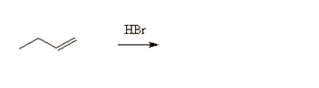
6. Predict the product that would show up from this reaction. Draw the structure and name it.
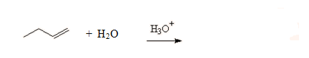

7. How do the terms electrophile, nucleophile, Lewis Base, Lewis Acid, Bronsted-Lowry acid and Bronsted-Lowry relate?

8. Using the following chemical equation, identify the acid, base, conjugate acid and conjugate base.
